DAGOR NON-WOOD FOREST PRODUCT MANAGEMENT PLAN
SHUMAR GEWOG: PEMAGATSHEL DZONGKHAG

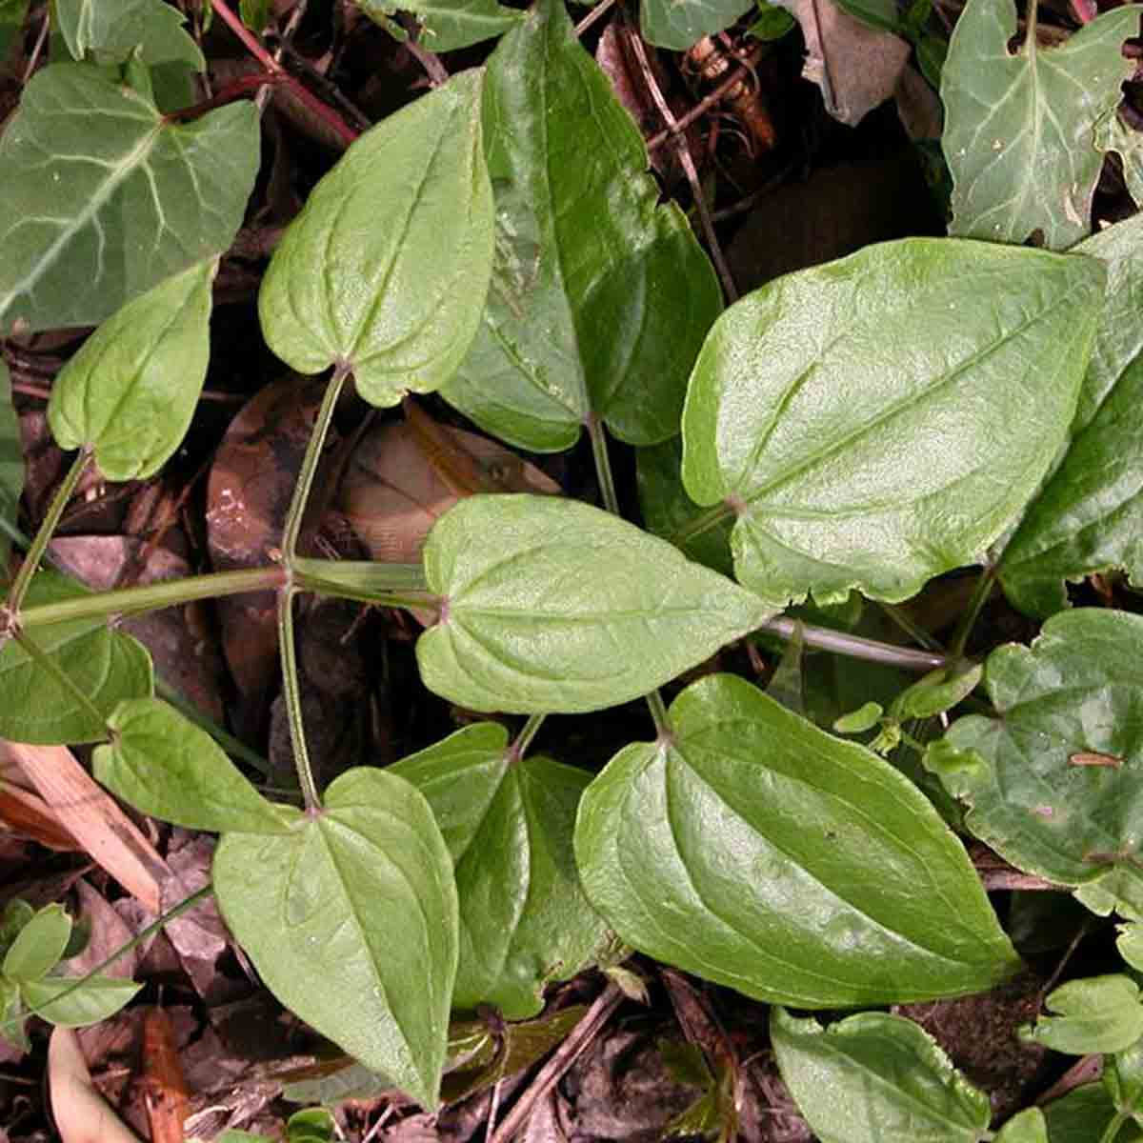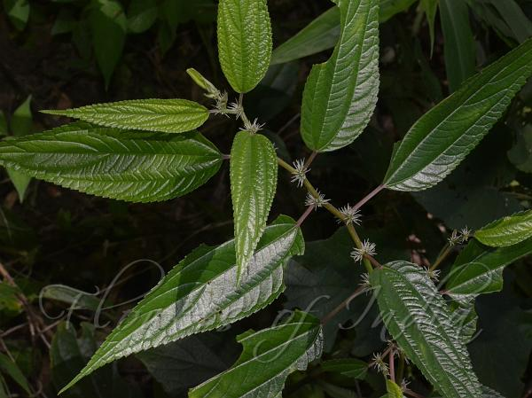



MANAGEMENT PLAN PERIOD: 2021-2026
Contents
GLOSSARY AND ABBREVIATIONS iv
EXECUTIVE SUMMARY 5
PART 1: BACKGROUND INFORMATION 6
1.1: Short descriptions of Pipla (Piper pedicellatum) 6
1.2: Short descriptions of Rubia (Rubia cordifolia) 6
1.3: Short descriptions of Youngjiva (Pouzolzia sanguine.) 2
PART 2: NWFPS MANAGEMENT AND MARKETING PLAN 3
2.1: Objectives: 3
2.2: NWFPs descriptions 3
2.3: Harvesting prescriptions for sustainable harvesting 4
2.4: Map of the collection areas: 4
2.5: Marketing and sales plan 6
2.6: Collection and Marketing scheme 6
PART 3: BY-LAWS: Group regulations and norms 7
3.1: Members of the NWFP management & marketing group 7
Membership 7
Responsibilities and rights of members: 7
3.2: Committee members and responsibility 8
Chairperson 8
Secretary 8
Treasurer 8
3.3: Compensation to the executive committee for marketing 9
3.4: Membership fee and purpose 9
3.5: Community development fund and utilization of fund 9
3.6: Conflict resolution 9
3.7: Penalties 10

List of Tables
Table 1: Brief description of individual NWFPs species 3
Table 2: Harvesting prescriptions for sustainable harvesting 4
Table 3: Marketing and sales plan of NWFPs 6
Table 4: GPS Coordinates of the prominent features and places. 11
List Figures
Fig1: Piper pedicellatum 6
Figure 2: Rubia cordifolia & its processes 2
Figure 3. Pouzolzia sanguinea 2
Figure 4. Dagor Google map 5
Figure 5. Dagor NWFP map 5

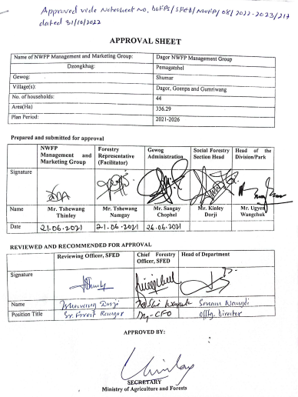

GLOSSARY AND ABBREVIATIONS

CFD Community Development Fund
CFO Chief Forest Officer
DoFPS Department of Forests and Park Services
GFEO Gewog Forestry Extension Officer
HHs Households
masl Meter above sea level
NTFPs Non-timber Forest Products
NWFPs Non Wood Forest Products
ToR Terms of Reference

EXECUTIVE SUMMARY
Dagor Shingmen Nagtshel Duethsen (NWFP) Management Group comprises of 44 households from Dagor, Gumriwang and Goenpa village under Shumar Geog, since its inception in 2017. The group collected nine different types of NWFP species in the past plan period. Nevertheless, due to the decline in production, market price and demand for some NWFP species, they are collecting only Pipla (Piper pedicelatum), Youngjiba (Pouzolzia spp.) La-nyee roo (Rubia cordifolia).
Only those three species have potential for collection during this plan period if they strictly abide with the harvesting prescription of the plan. Those resources will be collected from nine designated collection sites specified in map for collection and management in this plan. The designated areas are dominated by three species of NWFPs. The sustainable management and utilization of those resources may help in both future NWFPs resource management and income generation.
In the past, the income generated from the sale of NWFP helped the members to meet expenditures for their school going children and buying essential grocery items. They also learned the techniques to harvest NWFPs in sustainable manner. The group members managed to accumulate total fund of Nu. 46,870 through varies contribution from individual members by sale of NWFP collected.
Management Plan consists of the brief description of NWFPs, descriptions of the species including harvesting prescriptions, maps of NWFPs harvesting areas and marketing sales plan. The by-laws of the management plan contained process of executive committee formation-ToR of Chairperson, Secretary and Treasurer, compensation to the executive committee for marketing, membership fee and community development fund, conflict resolution and penalties.
The term of management plan is for five years and will be effective from 2022 to 2026. During the period, the group will have right to collect mentioned NWFPs as per the harvesting guidelines prescribed in the plan and ensure sustainability of resources for future use.

PART 1: BACKGROUND INFORMATION

1.1: Short descriptions of Pipla (Piper pedicellatum)

Local name: (Pansay) is a perennial plant that grows as bushes to a height of 1-2 meter. It has smooth dark greenish leaves. Pipla is a dioceous plant, meaning that it has unisexual reproductive units with male and female plants separately. Only the female plants bear round berries that have commercial value. The fruits start ripening in August – September.

Pipla thrives widely under the canopy of broadleaf forests or in an open area within the altitudes ranges of 200-2200 masl in Pemagatshel Dzongkhags, and in some other sub-tropical forests around the country. It is the shade demander and thrives mostly in damp and moist soil.
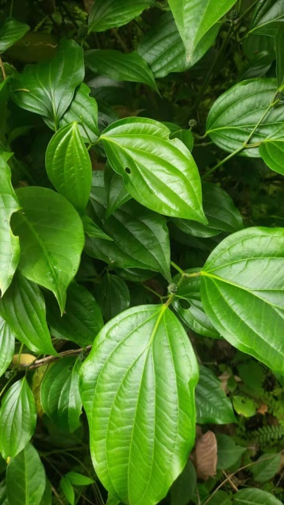
  - Fig1: Piper pedicellatum

Uses

The fruits have distinctive sour and hot taste that can be used for medicinal purposes, and also use as a species. In Bhutanese Medical Tradition, recognize Pipla as powerful stimulations for the digestive and respiratory system as a rejuvenating agent, longevity enhancer and tonic for the immune system.

1.2: Short descriptions of Rubia (Rubia cordifolia)

Rubia(local name Laniru)is a perennial scrambling or climbing herbs or sub-shrubs of around 80 species native to various parts of the world. It can grow up-to 1.5 m in height. The evergreen leaves are 5-10cm long and 2-3cm broad, produced in whole whorls of 4-7 star like around the central stem. It climbs with tiny hooks at the leaves and stem. The flower usually appears from June to August. It grows along the forest edge and clearings, scrub vegetation, dune forest, less commonly in grassland and open and rocky areas. It grows up to the elevation of 2600 masl.
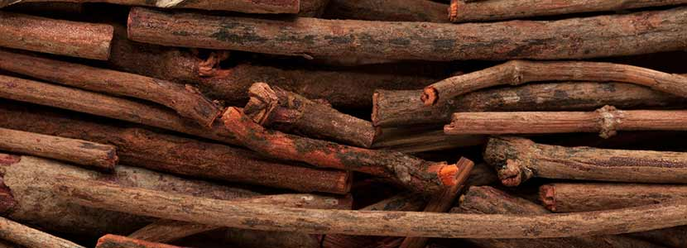
  - Figure 2: Rubia cordifolia & its processes

Uses
Rubia is an economically important source to use as colorant. The plants roots contain an anthracites compound that gives its red color to a textile dye. It also used as a colorant especially for paints. In Bhutan it is locally used in coloring and treating threads on weaving.

1.3: Short descriptions of Youngjiva (Pouzolzia sanguine.)

Pouzolzia sanguine is an evergreen shrubs growing in warm broadleaved forest, thickets and edge of woods, dry valleys, roadside and in the patches of abandoned cultivation at elevation of 300-2300 masl.


  - Figure 3. Pouzolzia sanguinea

Uses
A paste made from the roots of Pouzolzia sanguine is applied to boils. A fibre obtained from the barks is used in making rope, nets, etc. In Bhutan, it is popularly used as one of the ingredients in incense manufacturing process as it is adhesive in nature.

PART 2: NWFPS MANAGEMENT AND MARKETING PLAN

2.1: Objectives:
- Income generation from the sale of NWFPs.
- Sustainable management NWFP resource.
- Enhance rural livelihood with poverty reduction.

2.2: NWFPs descriptions

Table 1: Brief description of individual NWFPs species
NWFP name | Collection area (name) | Parts harvested | Use purpose (traditional and others) | Harvesting season (months) | Estimated quantity that can be collected
Pansay (Piper pedicellatum) | Ripaylaylay, Brongshing, Lhakhang Jab, Pumtang, Chongmashing, Paylay Yoe and Tongtongma | Fruits | Spices & medicine | Fruits are fully mature usually from October to January | 500 kgs
Rubia (Rubia cordifolia) | Phokcheri, Bainangwoong, Chongmashing & Namkhari Drupchu, | Entire plant | Dye/colorant | January to April | 100 kgs
Youngjiva (Pouzolzia sanguinea) | Chongmashing, Paylay Yoe, Ripaylaylay, Lhakhang Jab, Namkhari Druochu & Tongtongma | Bark | Adhesive and incense making | October to April | 2500 kgs

2.3: Harvesting prescriptions for sustainable harvesting

Table 2: Harvesting prescriptions for sustainable harvesting

NWFP species | Harvesting prescriptions for sustainable harvesting
Pansay (Piper pedicellatum) | - Collect fruits only when fully mature.  - Harvest fruits only on announced to start for harvesting (Date is usually announced by the coordinator in consultation with GFR as per the season mentioned in plan).  - Harvest fruits only by hand picking without damaging, cutting or uprooting of the entire plants.
La-nyee roo (Rubia cordifolia) | - Do not uproot entire plants.  - Do not collect roots.  - Use sharp scissors for the collection of upper part of the plant.  - Maintain 5 cm at the ground level while cutting the upper parts.  - To retain as the seed plant for natural regeneration, leave at least 10% of the plants without harvesting.  - Should collect after the announcement made by coordinator in consultation with GFR to collect on each season (As per the season mentioned in plan).
Youngjiva Pouzolzia sanguinea) | - To retain the stump for coppicing in the following growing season, maintain at least 10 cm to the ground level while harvesting.  - Do not harvest or collect the remaining young stands/seedling/saplings.  - Felling the surrounding trees to ease harvesting is prohibited.  - To retain as the seed plant for natural regeneration, leave at least 10% of the plants without harvesting.  - Collection of roots is strictly prohibited for ecological reason.

2.4: Map of the collection areas:
Although some of the area which falls under the community of Dagor was not included for collection in the previous plan, but the group has managed the area as it was found potential for collection. In this plan the area has been mapped in detail and is demarcated by Drangmechu to the west. Towards the south is demarcated by Demri, Waphai village to the north and Serlimkha village under Nanong as the eastern boundary.
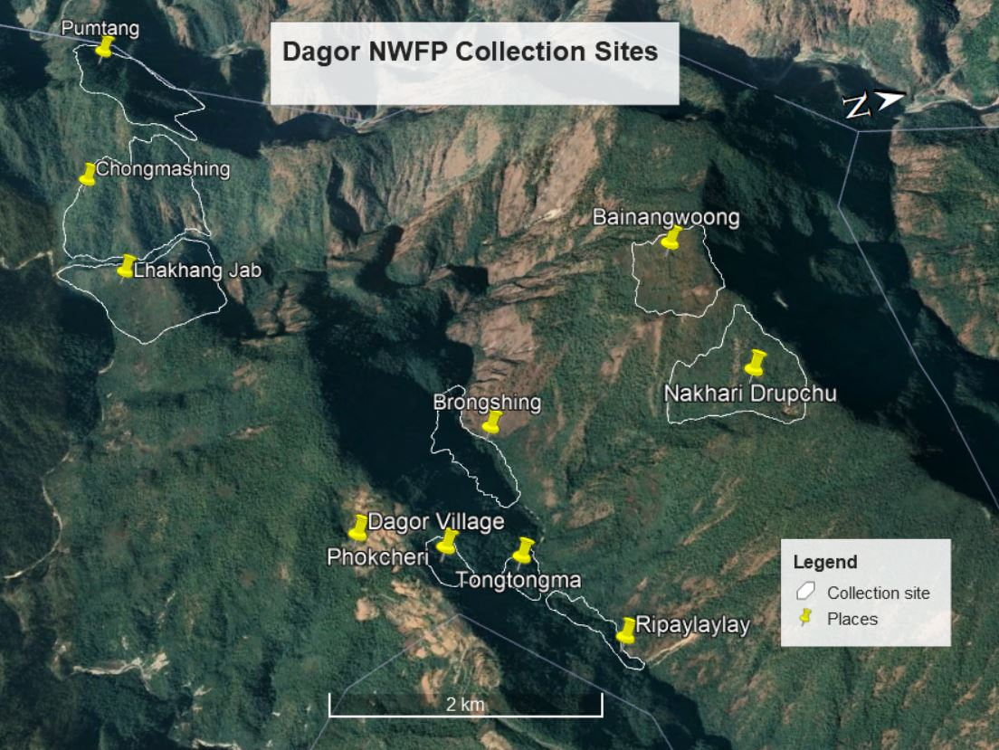
  - Figure 4. Dagor Google map
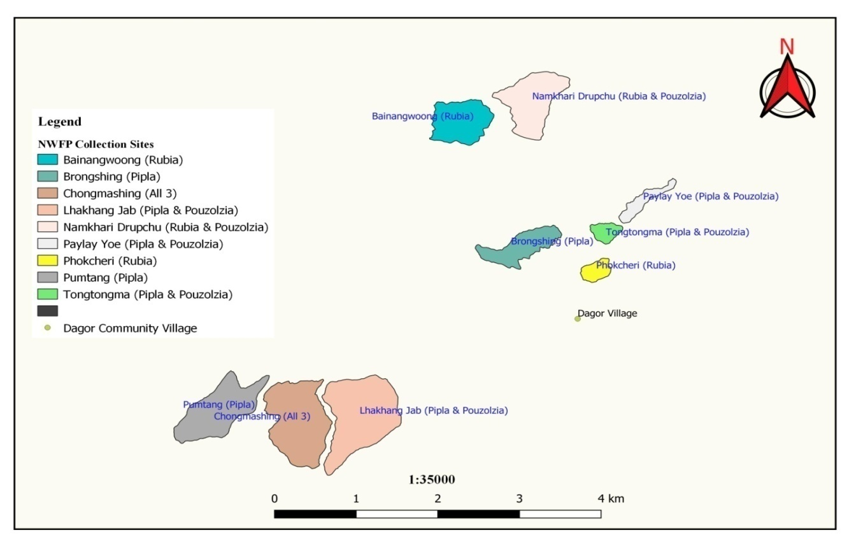
  - Figure 5. Dagor NWFP map

2.5: Marketing and sales plan

Table 3: Marketing and sales plan of NWFPs
NWFP name | Potential market | Estimated quantity for sale per season | Expected price per unit | Total Nu.
Thoksampa (Paris polyphylla ) | Trader holding trading license through auctioning by committee | 20 kgs | 2500 | 50000.00
Rubia (Rubia cordifolia) | Trader holding trading license through auctioning by committee | 2000 kgs | 50 | 100000.00
Youngjiva (Pouzolzia sanguinea) | Trader holding trading license through auctioning by committee | 1500 kgs | 50 | 75000.00

2.6: Collection and Marketing scheme

The chairman will bear the sole responsibility in obtaining the collection permit from the concern Forest Range Office a week ahead of the onset of the time. The coordinator shall announce the starting date, duration and the closing date in consultation with the GFR.
The group members will collect the NWFPs mentioned in this plan individually, after which they should store properly as per the market requirement demand and segregate products as per the standards required by the trader. The executive committee members will collect the NWFPs product to the auction yard and inform to the concern forestry official/DAMC. The concern forestry official/DAMC will then organize NWFPs auction to various NWFPs traders. The auction will be organized in the presence of Chairman from the respective NWFPs groups as a representative on behalf of the group.
The executive members may deduct the expenditure such as transportation, community fund and compensation before making payment to the group. The sharing of income to the individual group member will be done based on the quantity of NWPs collected by the respective members after deduction of all necessary expenditure.

PART 3: BY-LAWS: Group regulations and norms

3.1: Members of the NWFP management & marketing group

Membership
- The entire household having “Thram and Gung of Dagor chiwog are eligible to join the group provided they accept the terms and conditions of new member registration in the group.
- Any interested member willing to join the group up on fulfilment of above criteria shall put an application to coordinator.
- Up on receiving of application, decision will be taken during half yearly general meeting and should get 50% or more votes from the existing members.
- Up on fulfilling aforementioned terms the member will get register with the payment of compensation amount equivalent to individual member contributed till date in the saving account of the group.

Responsibilities and rights of members:
- The group members participating in this management of NWFP will have equal rights and responsibilities for controlling, protection, management and harvesting in the identified collection areas.
- The individual members will have the equal rights to only after chairman fixed the date and time.
- Every member of the group will have equal access to resource and report to the committee members for violation of the management rules.
- The members should agree to sell the collections only through the group and not individually.
- Any member withdrawing due to loss of interest from the membership shall be allowed without any benefit and he/she will not be allowed to re-join the group.
- Resignation from the group membership, owing to age or no one to inherit in the group will get his/her share contributed till date of his/her resignation up on verification and approval from committee.
- The group shall conduct meeting twice to discuss on work plan and group related issues.

3.2: Committee members and responsibility
Sl. No. | Name | Gender | Designation | Contact no. | Remarks
1. | Tshewang Thinley | Male | Chairperson | 17872462
2. | Phuntshok | Male | Secretary | 17704294
3. | Tshering Dema | Female | Treasurer | 17989992

Chairperson
- To chair all kinds of meeting related to this NWFP management plan.
- To obtain collection permit a week before from the Forest Range Office as mentioned in the harvesting guideline.
- Fix date of collection and make an announcement to the group member
- To inform the members and collect NFWPs for auction.
- To confirm date and time for auction in consultation with GFR/DAMC and inform traders accordingly on venue and time.
- To resolves the disputes and conflict among the members.
- To enforce the fine and penalty as per the norms of the group.
- To submit final report of the product type and income generated to the Gewog Forest Office and whenever deems necessary.
- Act as the overall manager of the group fund.

Secretary
- Look after the roles of chairperson in his absence.
- Provide assistance to the Chairman.
- Maintain records of the activities implemented.
- Write official correspondence and maintain minutes during meeting conducted.

Treasurer
- To maintain all financial matters and present during the annualgeneral meeting to Committee and the group members.
- Officiate and assist the Chairperson or Secretary in their absence in functioning of the group.
- Collect the annual membership fee of nu. 50/- each.

3.3: Compensation to the executive committee for marketing
The executive members during involvement in related activities shall be paid an amount equal to the existing national wage rate (Nu. 215/day) from the group fund and agreed to serve as committee for the period of next 5 years

3.4: Membership fee and purpose
- Membership fee for the existing group should pay Nu. 50/- annually.
- The collected fee will be deposited in the joint account as a Community Development Fund (CDF) that will be used for pre-financing marketing purposes and others.

3.5: Community development fund and utilization of fund
- Individual member should contribute 5% of the total income generated from the sale of each product. However if the deduction made from sale of each product does not reach to a sum of nu. 100/- the deficit amount should be added and contribute to the group fund. (minimum amount of nu.100/- from the sale of each product to the group fund and if no NWFPs were collected the group shall abstain from collecting from the members).
- The fund collected in the group fund will be utilized for the group works upon general agreement. In case of huge amount accumulation in the bank, it will be landed on loan with the interest rate of 15% per annum within the group.

3.6: Conflict resolution
- In case there is a conflict between the NWFP Group and outsiders, the case shall be forwarded to the Divisional Forest Office/Gewog Administration and if could not resolve, the case will forwarded to higher authority.
- Any conflict or dispute on NWFP matters arises among the group members, the matter will firstly resolve by the Chairman.
- If the nature of the conflict is unable to resolve by the Chairman, the case will be forwarded to the GEFO for further settlement.
- Still if the conflict remains unresolved the case will be forwarded to the Divisional Forest office/ Gewog Administration.
- If the Divisional Forest Office/Gewog Administration cannot resolved the problems, the case will be forwarded higher authority for further action

3.7: Penalties
- In case if the member of the NWFP Group violates the harvesting rules as set in this plan, he or she will charge a fine amount of Nu. 1000/- and not be allowed to harvest the NWFP for the rest of the season.
- Members collecting the NWFP prior to the fixed date/announcement made by the Coordinator/ GEFO, the offender will be levied fine Nu. 1000/- with the confiscation of product and material used.
- Illegal and individual selling of the NWFPs will be imposed a fine of Nu. 10000/-
- Those members who could not collect it owing to old age or death or other should contribute nu. 100/- for each product during the time of marketing.
- Non-members without registering will be not allowed to collect and fine of Nu. 5000/- will be imposed and product will be seized to the group.
- An absentee during meeting is liable to pay Nu. 100/- per occasion and late submission of membership fee from the schedule date 100% of amount suppose to collect.

Table 4: GPS Coordinates of the prominent features and places.
Sl. No | Place Name | Latitude | Longitude | Remarks
1 | Ripaylayay | 27.139010 | 91.417626
2 | Brongshing | 27.133236 | 91.399215
3 | Bainangwong | 27.147144 | 91.391115
4 | Namkhari Drupchu | 27.150297 | 91.402245
5 | Phokcheri | 27.128780 | 91.409100
6 | Tongtongma | 27.133490 | 91.410200
7 | Chongmashing | 27.107766 | 91.370464
8 | Pumtang | 27.110542 | 91.359915
9 | Lhakhangjab | 27.109415 | 91.378742

